**Activity 13.5 - Mohammed Abdin**

**Submission Instructions:**

Your submission for this assignment should be a Word document that includes the following screenshots, each labeled for the step that the screenshot represents:

1. Provide a screenshot of the Activity13.5 folder in VS Code.

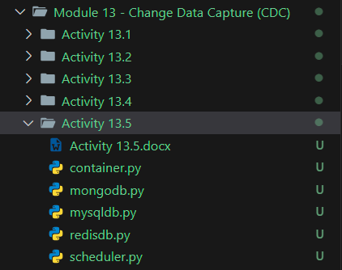

1. Provide a screenshot to show that you successfully added the code to create a Cassandra database *container*.

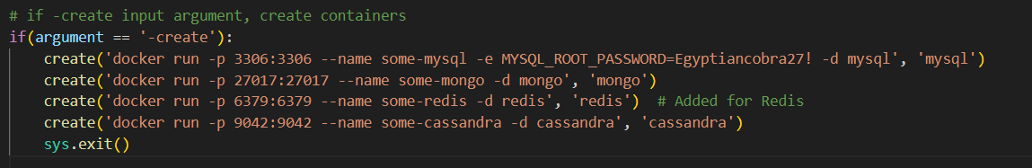

1. Provide a screenshot to show that you added code to delete a Cassandra *container*.

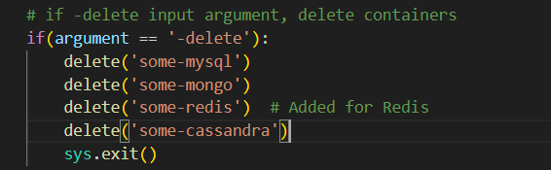

1. Provide a screenshot to show that you added a new file called cassandradb.py to the solution.

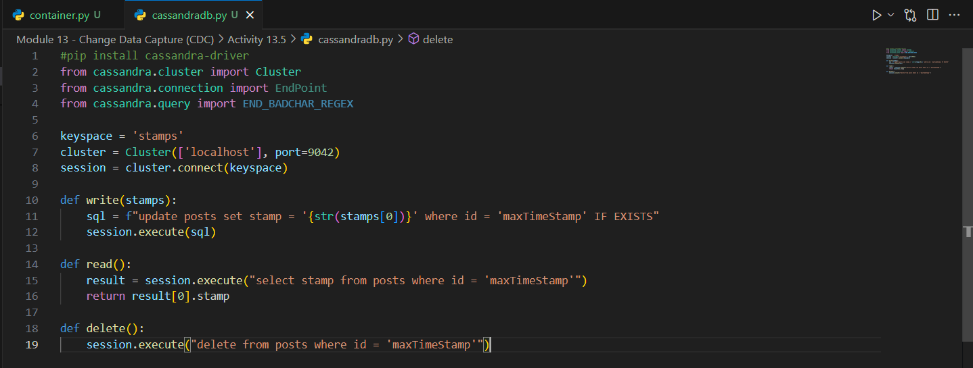

1. Provide the following three screenshots to show that you modified the container.py program:
   1. Provide a screenshot to show that you removed the comment to import Cluster.

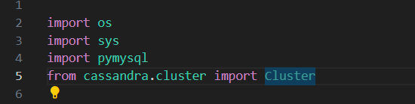

* 1. Provide a screenshot to show that you copied the init_cassandra() *function*.

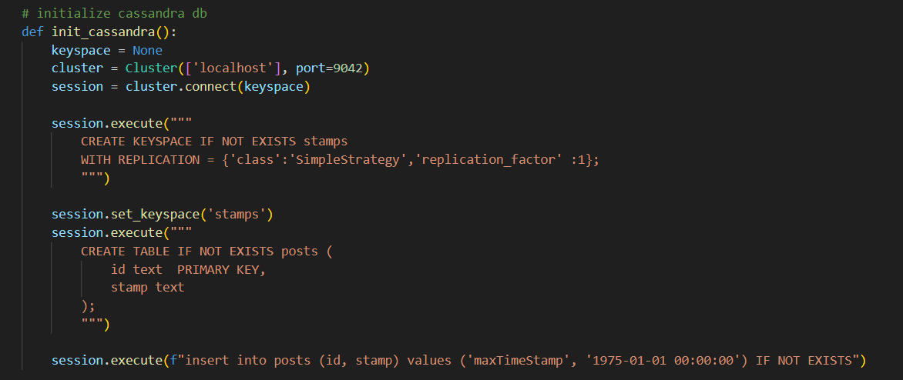

* 1. Provide a screenshot to show that you added a call to init_cassandra() when -init is passed as a parameter.

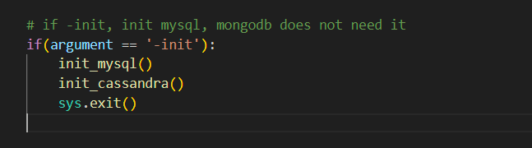

1. Provide the following five screenshots to show that you modified the scheduler.py program:
   1. Provide a screenshot to show that you uncommented the import *statement* to import cassandradb.

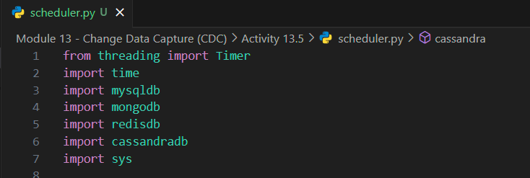

* 1. Provide a screenshot to show that you made a call to cassandradb.delete() in the clearout() *function*.

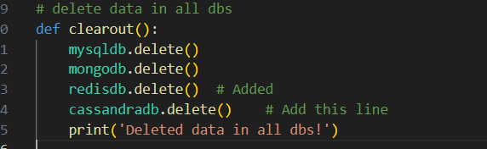

* 1. Provide a screenshot to show that you added the cassandra() *function*.

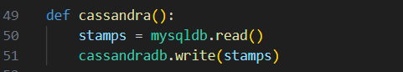

* 1. Modify the verify()*function* to read data from Cassandra.

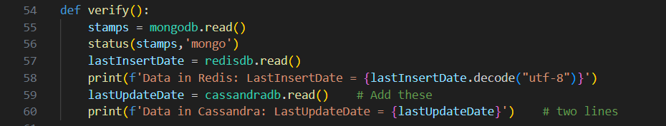

* 1. Modify the timeloop() *function*. Add a call to the cassandra() *function*. Provide a screenshot.

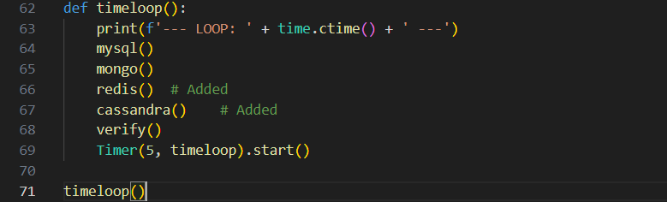

1. Provide a screenshot of your command prompt to show that you ran the container.py program passing -create as a parameter.

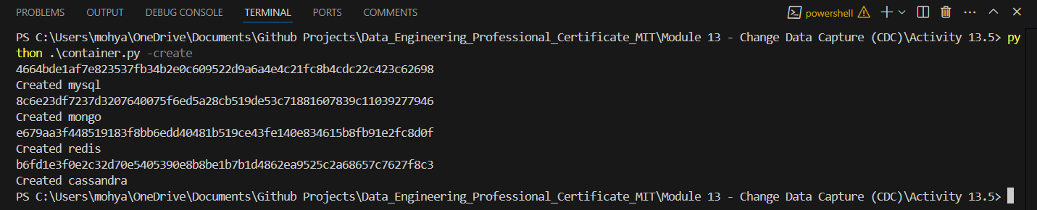

1. Provide a screenshot of your Docker desktop that shows all four database *containers* running.

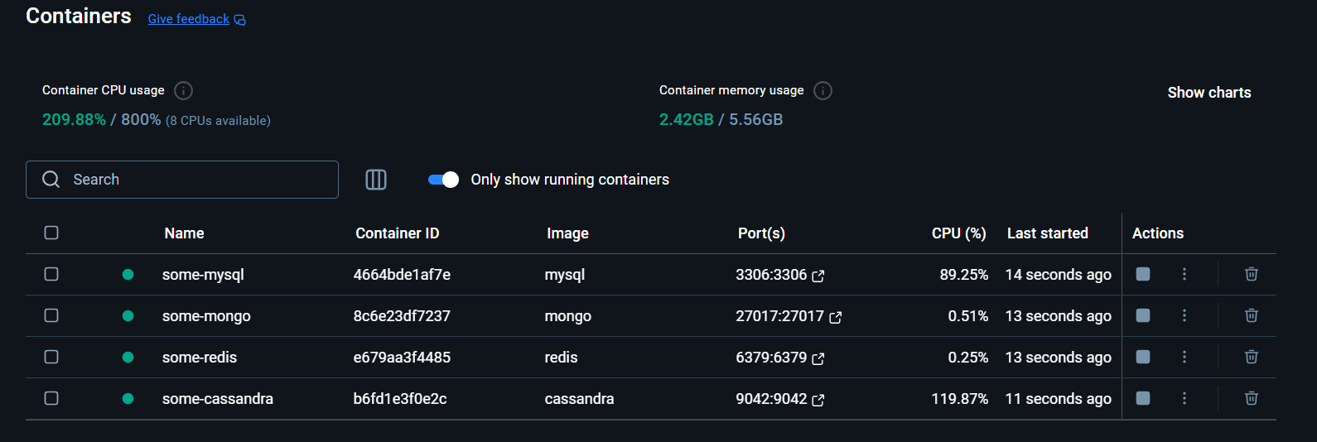

1. Provide a screenshot of your command prompt to show that you ran the container.py program passing -init as a parameter.

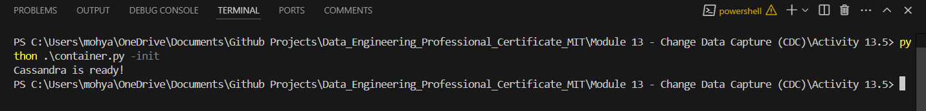

1. Provide a screenshot of your command prompt to show that you ran the scheduler.py program.

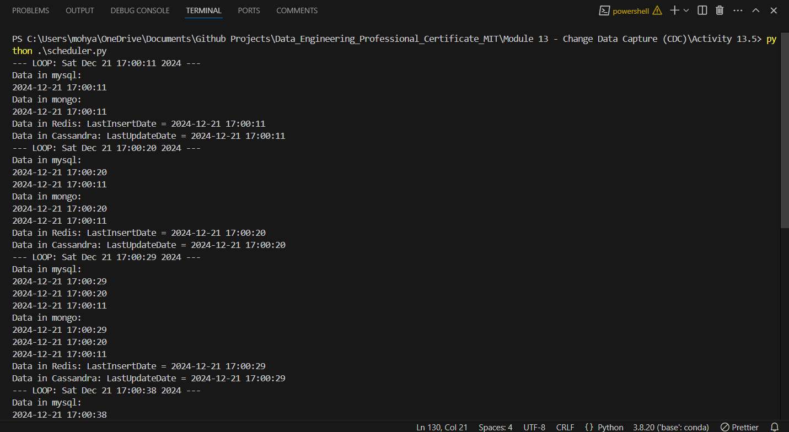

1. Provide a screenshot of your command prompt to show that you closed the window running the scheduler.py Python program and ran the container.py program passing -delete as a parameter.

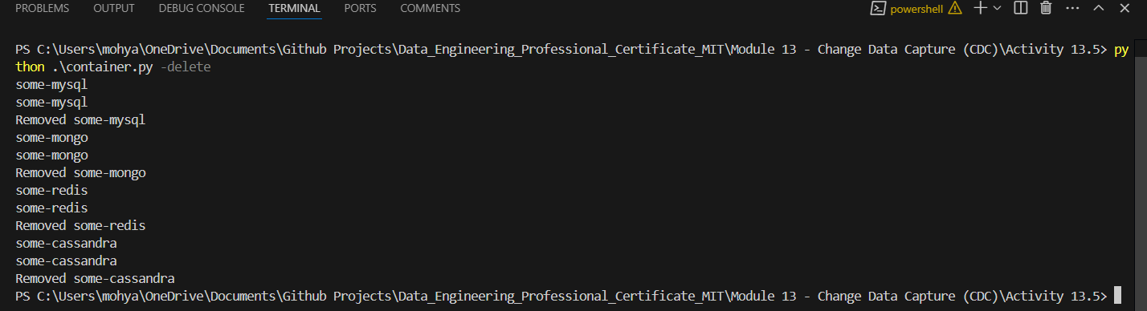

1. Provide a screenshot of your Docker desktop to show that all four database *containers* have been deleted.

